Computer Programming: CT
Why do we need programming languages?
Programming languages are needed to communicate between humans and computers.
Humans think in natural language, which can be ambiguous. But computers understand only machine language (0 and 1), which is exact and clear.
Since machine language is difficult for humans to understand, programming languages act as a bridge between human and machine.
They use strict rules (syntax and semantics) and can be translated into machine language by a compiler or interpreter.
There is a big gap between human thinking and machine understanding.
Natural Language: Ambiguous ("I saw the man with the telescope").
Machine Language: Exact (01001000).
Programming Language: A formal compromise (Strict rules, readable by humans).
What is Source Code?
Source code is the program written by a programmer in a high-level programming language such as C++, Java, or Python.
It is human-readable and follows specific grammar rules called syntax.
Source code cannot be executed directly by the hardware. It must be translated into machine language by a compiler or interpreter.
Example (Python):
print("Hello, World!")
What is Machine Code?
Machine code is the lowest level of software instructions.
It consists entirely of binary digits (0 and 1).
Machine code directly controls the CPU (Central Processing Unit).
It is hardware-specific, meaning machine code for Intel processors is different from ARM processors.
Example (Binary for "He"):
01001000 01100101
Only janar jonno
----------------
ARM এর পূর্ণরূপ হলো Advanced RISC Machine।
এটি একটি প্রসেসরের (CPU architecture) ধরন।
ARM প্রসেসর সাধারণত মোবাইল ফোন, ট্যাবলেট এবং এমবেডেড সিস্টেমে ব্যবহৃত হয়, কারণ এটি কম বিদ্যুৎ খরচ করে এবং কার্যকরভাবে কাজ
Alhamdulillah 🤍 খুব ভালো লাগলো শুনে।
নিচে তোমার পুরো বিষয়টা exam-friendly English version করে দিলাম — simple, clear, and easy to write in exam.
Translator
A Translator is a system software that converts High-Level Source Code into Low-Level Machine Code.
Source Code (C++/Python) → Translator → Machine Code(010101)
There are two main types of translators:
1. Compiler 2.Interpreter

1. Compiler
A Compiler translates the entire program at once and creates a separate executable file.

Process:
Read all code → Check errors → Build executable file

Analogy:
Like a translator who translates a whole English book into Bangla before anyone reads it.

Pros:
✔ Execution is very fast (CPU runs the binary directly).

Cons:
✘ If one line is changed, the whole program must be recompiled.

Compiler Execution Flow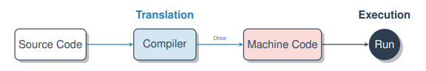
2. Interpreter
An Interpreter translates and executes the program line-by-line.

Process:
Read Line 1 → Execute
Read Line 2 → Execute
Analogy:
Like a live interpreter who translates a speech while it is being delivered.
Pros:
✔ Easy to debug (stops exactly where the error occurs).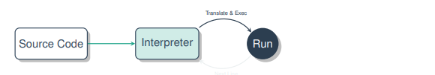

Types of Errors
During program execution, different types of errors can occur.
There are mainly three types of errors:

Syntax Error
A Syntax Error happens when the grammar rules of the programming language are violated.
It is detected by the compiler or interpreter.
Example:
Missing a semicolon (;)

Logical Error
A Logical Error occurs when the program runs successfully but produces the wrong result.
It is usually found by the programmer (human).
Example:
Calculating 2 + 2 = 3 instead of 4

Runtime Error
A Runtime Error happens while the program is running and may cause the program to crash.
Example:
Dividing a number by zero.
Algorithm:
An algorithm is a step-by-step procedure or a set of rules to solve a problem. It is language independent, which means you can write it in simple English first and then implement it in any programming language like C++, Java, or Python.
Example (Making Tea Algorithm):
- Boil water.
- Add tea leaves.
- Pour into a cup.
- Add sugar.
Note: An algorithm tells what to do step by step, not the actual code.
Characteristics of a Good Algorithm:
- Input: Can take zero or more inputs.
- Output: Must give at least one result.
- Definiteness: Every step should be clear and easy to understand.
- Finiteness: Must finish after a limited number of steps.
- Effectiveness: Steps should be simple and doable.
Pseudocode
Pseudocode (False Code) is a way of describing an algorithm using a mix of plain English and code-like structure.
It ignores strict syntax (no semicolons needed).
It helps programmers plan logic before worrying about grammar.
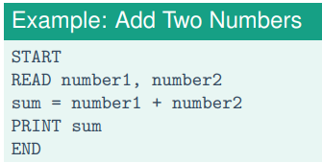
Control Flow Graph (CFG):
A CFG shows all possible paths a program can take during execution.
Parts:
- Nodes: Represent basic blocks (a sequence of instructions without jumps).
- Edges: Show control flow (jumps or branches).
Rules:
- Assign a node number to each expression.
- Draw a directed edge A → B if B executes after A.
- For branches, mark edges as True or False.
Problem:
Write a program to check if a student Passed or Failed. (Pass Mark = 40).
We will look at: 1 The Algorithm. 2 The Pseudocode. 3 The Control Flow Graph.
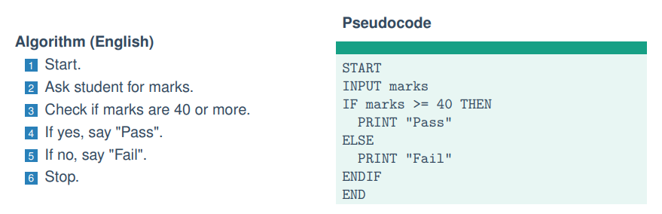
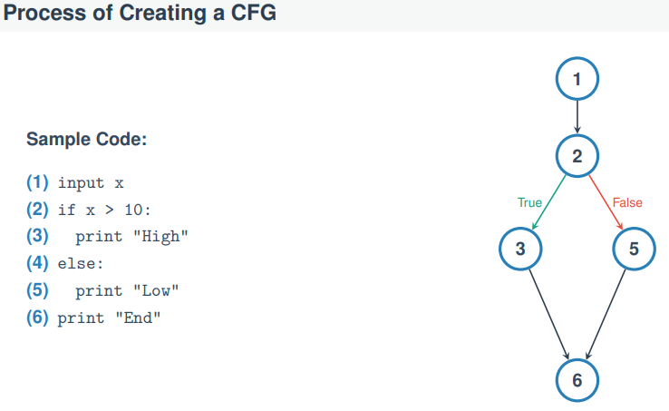 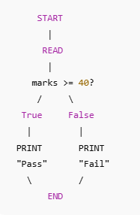

Big-O Notation
Definition:
- Big-O notation (O) shows the worst-case scenario of an algorithm.
- It tells the maximum time an algorithm can take.
Notation:
- If f(n)=O(g(n)), then g(n) represents the upper bound of time complexity.
Example – Linear Search:
- Problem: Find value 7 in the list [1,2,3,4,5,6,7]
- Worst Case: The number is at the end of the list.
- Work: Must check all n elements.
- Result: O(n)→ Linear time.
Key Point:
Big-O always considers the maximum work an algorithm can do, not the best case.
Big-Omega Notation
Definition:
Big-Omega (Ω) shows the best-case scenario of an algorithm. It tells the minimum time an algorithm requires.
Example – Linear Search:
- Problem: Find value 1 in the list [1,2,3,4,5]
- Best Case: The number is at the first index.
- Work: Check only 1 element.
- Result: Ω(1)→ Constant Time.

Big-Theta Notation (Θ)
Definition:
- Big-Theta (Θ) shows the average or tight bound of an algorithm.
- It gives both the upper bound and lower bound of time complexity.
When to Use Θ?
- When Best Case and Worst Case are different (like Linear Search), Θ is more complex to determine.
- When an algorithm always takes the same time for every input, then: O(1)=Ω(1)=Θ(1)
Example:
- Accessing an array index always takes constant time.
- So, its complexity is Θ(1).
How to Calculate Complexity (Code Example)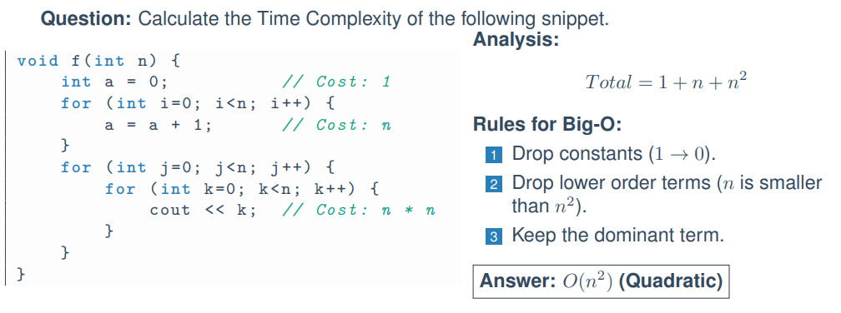

The Compilation Process
When we click “Build” in C++, the source code goes through three main stages:

1. Preprocessing
- Handles all commands starting with #
- Example: #include <iostream>
- It copies header file contents into the program.
- Cleans the code for the compiler.

2. Compiling
- Converts source code into machine code (Object file)
- Checks for syntax errors
- If no error → generates an Object file (.obj or .o)
- This file is incomplete (missing libraries).

3. Linking
- The Linker connects your object file (.obj / .o) with external libraries.
- It combines all required files to create the final executable file (.exe).

Example:
- When you use cout (print), the printing code is not inside your file.
- The Linker takes that code from system libraries and attaches it to your program.
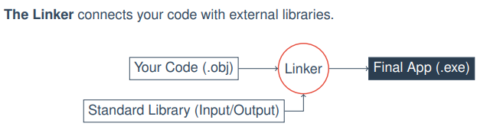

Question:
1. Statement dibe solve korte hobe tarmane Algorithm design korte hobe.
2. Algorithm dibe pseudocode likhte hobe
3. Algorithm to Pseudocode to CFG korte dibe.

